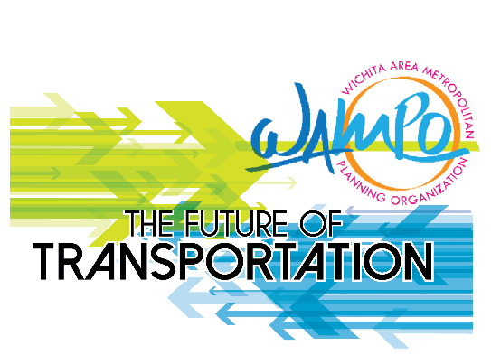

The Wichita Area Metropolitan Planning Organization (WAMPO) is seeking your support in helping to spread the word to encourage public participation in the Future of Transportation Survey effort. The survey will gauge perceptions on transportation priorities and future innovation – such as driverless cars. The survey, which is available in English and Spanish and is open until March 27: http://www.wampo.org/get-involved
Here are a few ways you can help spread the word between now and March 27. Thanks for your assistance.
INCLUDE IN EMAIL NEWSLETTERS – Recommended wording to accompany the included digital flyer and video:
We want to know your thoughts on the future of area transportation
We’re inviting all residents to give their thoughts on what you believe is most important about area transportation options and how you feel about advances in technology— such as with driverless cars.
Your opinion matters and will help transportation authorities to determine what investments to make for current priorities and future needs.
To access the survey link and to learn more about the topic, please click here: http://www.wampo.org/get-involved
PLACE ON SOCIAL MEDIA – Recommended posts:
Facebook: Driverless cars? Bike lanes? Ride shares? You’ve got opinions on transportation and @wampoks wants to know them. Please take a moment and share your thoughts: http://www.wampo.org/get-involved
#futureoftransportation
Requesting your feedback on the future of transportation: http://www.wampo.org/get-involved
@wampoks #futureoftransportation
Flying cars in Kansas? Learn more about the @wampoks Future of Transportation Survey from the @cityofwichita briefing. Begins at the 3:48 mark: https://www.facebook.com/cityofwichita/videos/148923916265344/
Twitter: Rideshares, bike lines & advances in tech. Thoughts about KS-area transportation? https://bit.ly/2TUGGpM @wampoks
Instagram: insert project logo. Caption: Everyone has thoughts on transportation. Share yours! Link in comments. #futureoftransportation #kansas
POST FLYERS ON PUBLIC BOARDS
INCLUDE IN CONSTITUENT MAILINGS, NEWSLETTERS, ON PUBLIC BROADCASTS, ETC.
Social Media Graphic:
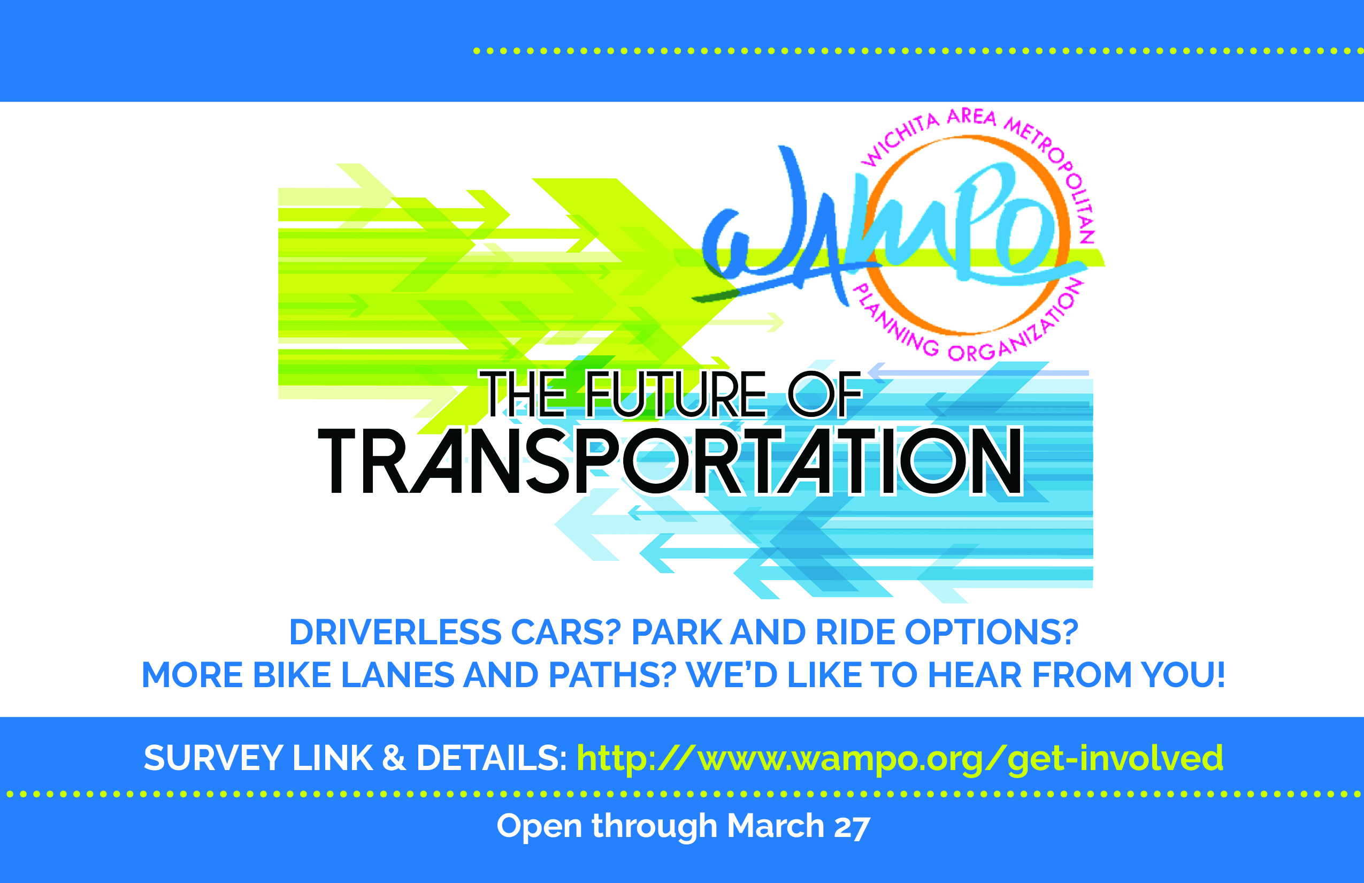

Flyer Image:
